IS-12: IT Support for Office Management

**Project**

Course Instructor

***Professor Dr. Ahsan Habib***

***IICT,SUST***

Submitted by

MD.Towhidul Islam

IS-12-23





FIELD TRIP REPORT- 2024

KUAKATA, PATUAKHALI

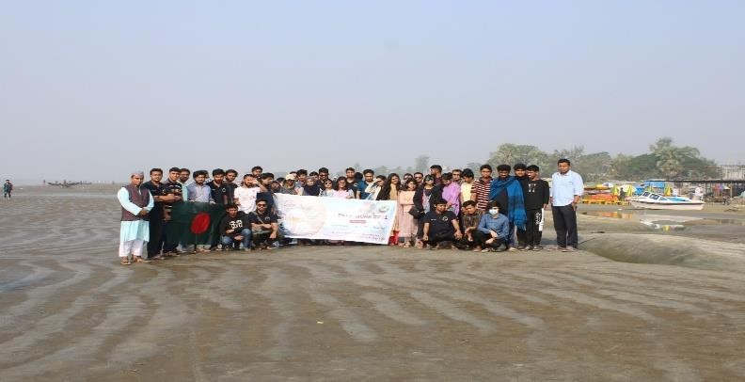

**SHAJALAL UNIVERSITY OF SCIENCE &TECHNOLOGY, SYLHET**

**ABSTRACT**

Department of Oceanography at Shahjalal University of Science & Technology (SUST) has organized a field trip to give students a practical observation of mangroves and the brackish water ecosystem, Water, plankton, and sediment samples are collected from seven different stations around Kuakata Sea beach region and preserved for laboratory analysis under our honorable teacher MD. Solaiman Hossain, assistant professor, department of oceanography, SUST. Abu Bokkar Siddique, Lecturer, department of oceanography, SUST. Different tools are used during this field trip, including a plankton net, grab sampler, a global positioning system (GPS), CTD, DO meter, and Phytoplankton net. The water samples are also analyzed to understand the water quality of Sundarbans. The major physical parameters such as pH, DO (dissolve oxygen), temperature, salinity, etc. This field trip was held from December 9th, 2021, to December 13th, 2021.

# Introduction:

Education gets its completeness when it can be applied in our practical life to improve our lifestyle. The knowledge which cannot be applied in daily life is worthless. So, it is compulsory to gain practical knowledge besides theoretical knowledge and one of the ways for gaining practical knowledge is through a field trip.

A field trip is any kind of visit made by students and teachers for the purpose of firsthand observation (according to Merriam-Webster). The purpose of the trip is usually observation for education, gaining practical knowledge, non-experimental research, or providing students with experiences outside their everyday activities.

**OBJECTIVES**:

To bridge the gap between education and practical knowledge, the Department of oceanography, Shahjalal University of Science and Technology, organizes field trips as a part of the course **OCG-**

**310**. From 09-13 December 2021 at Kuakata with 62 students, two instructors, and one coadjutor In charge of the field trip, our honorable Assistant professor Md. Solaiman Hossain, Lecturer Abu Bokkar Siddiqque, Department of Oceanography, Shahjalal University of Science and Technology. In this field trip, our main objectives are:

* To Acquire Knowledge
* To learn the uses of instruments
* To visit a fish landing zone & its operation including identification of common fish found.
* To compare the biodiversity of Kuakata.
* To collect sediment samples and data on turbidity.
* To learn the usage of CTD and data collection of temperature, pressure, depth, and electric conductivity.
* To visit a port and learn about its operations.

## Chapter-01: Visited Field Work Sites:

|  |  |  |  |
| --- | --- | --- | --- |
| **Day number** | **Date** | **Visited site** | **Time of visit** |
| Day 1 | **10/12/24** | 1. Bangladesh Fisheries Research Institute (BFRI), Khepupara, Patuakhali, Barisal | **2: 45 pm** |
| Day 2 | **11/12/24** | 2.Mohipur fish landing center | **7:46 am** |
| 3.Gangamatir Char | **9:40 am** |
| 4.Fatrar Char, Tin nodir mohona | **3:00 pm** |
| **Day 3** | **12/12/24** | **5.Payra seaport** | **2:30 pm** |

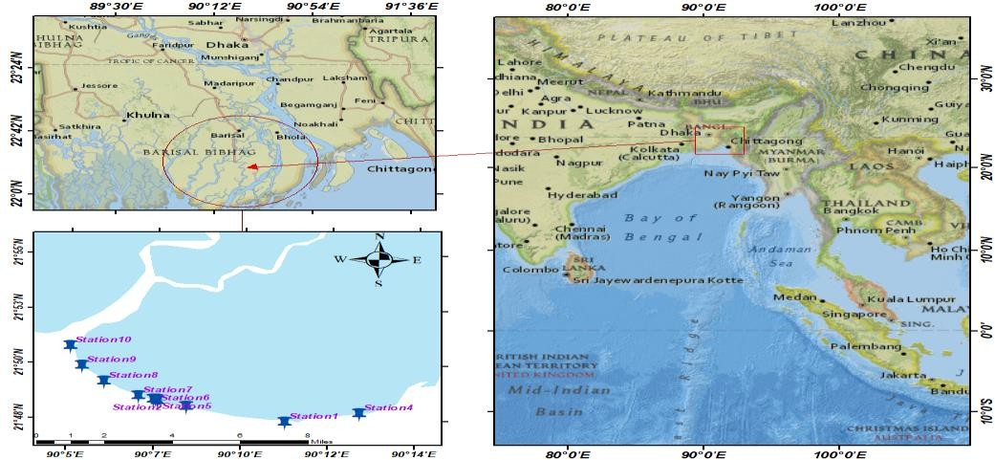

***Figure-1*:** Study Area of Kuakata

**Day-1, Location-1**: Bangladesh Fisheries Research Institute (BFRI)

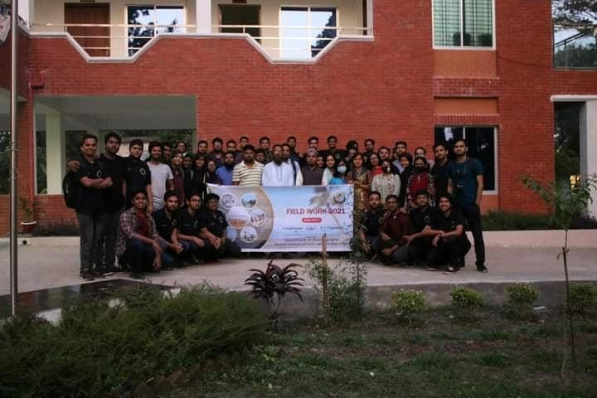

***Fig-2****:* BFRI, Patuakhali

We arrived in BFRI, Patuakhali, on December 10, 2024. We learned a lot about the BFRI research project by watching the video and listening to the scientific officers. We also learned how the projects and oceanographic research are related. They are primarily concerned with developing innovative techniques and technology to boost Bangladesh's fishing sector. Some of the innovations they created are Advanced Nursery Management of Rui Fish, Production, and cultivation of BFRI Super Tilapia fry, Production of lobster fry at the home hatchery, and many more. Bangladesh is currently the world's fourth-largest fish producer, thanks to innovative technology. They are currently working on three projects. The projects are as follows:

1. Seaweed culture and production of seaweed products on the coast of Bangladesh
2. Oyster culture and breeding
3. Mariculture of Seabass

After seeing the documentary and listening to the briefing we went to see the lab facilities of BFRI. There we saw a variety of instruments with various use cases. They use these instruments for experimenting and collecting data from various samples. The instruments were:

* + Soxhlet extractor,
  + HPLC
  + Water treatment plant
  + Spectrophotometer
  + Water Bath

#### Soxhlet extractor:

When attempting to extract lipid from a solid substance, a Soxhlet extractor is utilized. This approach is typically used to generate satisfactory results when the target molecule has limited solubility in a solvent and the impurity is insoluble in that solvent.

Working procedure: An arm of distillation delivers the solution to the chamber with the solid by refluxing it. The vapor cools and returns to the solid chamber. Warm the solvent in the solid- filled container. As the solubilizer heats up, it dissolves a portion of the chemical. To drain the nearly full Soxhlet chamber, the siphon is employed. Replace the solvent.

***Fig-3****:* Soxhlet extractor

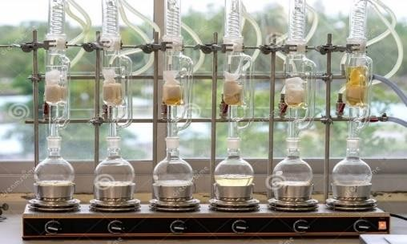

Fig: Soxhlet extractor

### HPLC

In liquid chromatography, different things are separated. A technique called "analytical liquid chromatography" uses HPLC to separate and identify the parts of a mix. It is divided into two parts:

* + 1. mobile phase(eluent) and
    2. stationary phase (packing material of the column).

Working procedure: According to the analyte's chemistry, molecules move slowly through the stationary phase. A sample's "on-column" time is determined by the amount of time it spends in touch with other molecules. So, the sample elutes in different parts, which is how it works. The sample ingredients were split up. Front of the column is a device that can be used to find out what is going on (like a UV detector). A data management system (software) converts, records, and shows the signals as a chromatogram, which looks like a bar graph.

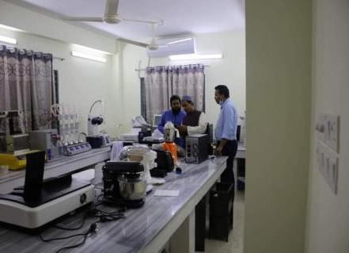

***Fig 4***: HPLC machine

#### Water treatment plant

In a lab, a water treatment plant is used to distil water, which removes more than 99.9% of contaminants, such as chemicals, heavy metals, microorganisms, and sediment. Water distillers can have different designs, but they usually have a boiling chamber, cooling system, and a separate tank to store the water.

Working procedure: In the boiling chamber, water is put in. The machine is plugged into a power source and turned on. The boiling chamber will then heat up to the point where water boils, and then it will be ready to be used. There is a lot of steam in the cooling system because water evaporates into it. Into a clean container, it goes down an embankment. It condenses and drips into a new one. Most of the things that aren't water don't boil at the same temperature as water.

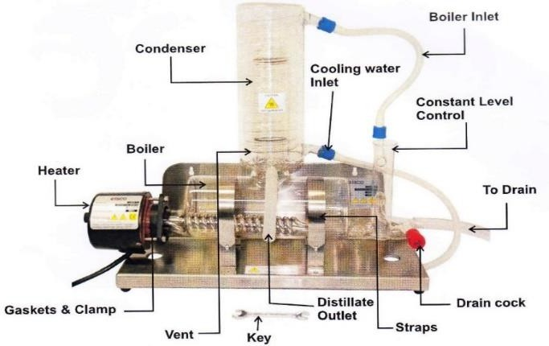

***Fig 5:*** water treatment plant

## Spectrophotometer:

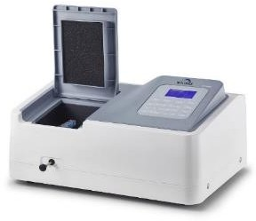A spectrophotometer is a tool for measuring the amount of visible light, ultraviolet light, or infrared light that comes out or comes back. They use the wavelength of the light source to figure out how much intensity there is.

***Fig 6*:** spectrophotometer

Working procedure: It comes from a lamp. It's like a mirror, and it splits the light into the different wavelengths that make up each one. There is only one wavelength of light able to pass through the exit slit. Then, the sample and the light work together.

1. Water bath There is a piece of lab equipment called a water bath. It is a container filled with heated water. It is used to keep samples in water at the same temperature for a long time. Almost all water baths have either a digital or an analog interface that lets users set the desired temperature.

This method could be used when the temperature is too high for the usual method, like a silicone bath, an oil bath, or sand. There are three types of water baths:

* 1. Circulating water baths

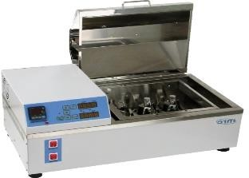

* 1. Non-circulating water baths
  2. Shaking water baths

***Fig 7:*** water bath

# Day-01, Location 2: Mahipur Fish Landing Center:

The next day at 7:46 am we reached at Mahipur fish landing center. A fish landing center is a place where various types of fish and fish-related commodities arthere fromom sources like Estuaries, rivers, pond, haor, beel, gher and sea (BFDC 2001). There are many fish landing centers in the coastal zone of Bangladesh. Mahipur, Kuakata is one of them. Both inland (freshwater) and marine

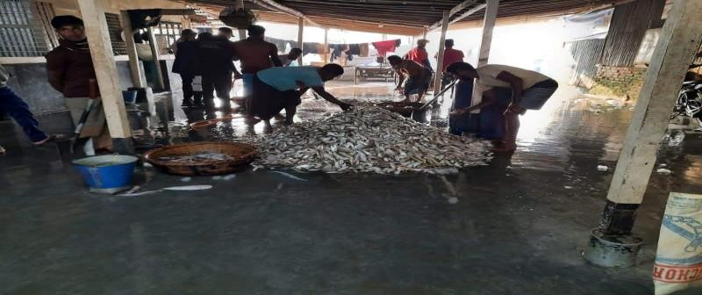

**Fig 8:** Mahipur fish landing center

(Brackish water) water fish species are found in Mahipur fish landing center. During our visit we have talked with the fishermen. They told us about their livelihood and how they collect the fish. During our visit, we tried to identify the indigenous species that are available in the landing center. We have identified a total of 8 species, that are listed below:

|  |  |
| --- | --- |
| 1. **Boiragi**   English Name: **Goldspotted grenadier anchovy**  Scientific name: ***Coilia dussumieri***  **Characteristics**:   * 1. Elongated Body with small scales. Maximum length is 15.5 cm.   2. Compressed and with a very slender tail.   3. Belly somewhat rounded with 5 or 6 sharp scutes before pelvic base and 7-9 after pelvic base.   4. Pectoral with 6 long filaments.   5. 65 scales in median lateral series (Rahman, 1989 and 2005). |  |
| 1. **Dandi**   English Name: Flathead sillago Scientific name: ***Sillaginopsis panijus* Characteristics**:   * 1. Body elongated with depressed head and snout.   2. Eyes 3-11% of head length.   3. Two dorsal fins, second spine of first dorsal fin very elongate and filamentous.   4. Eyes are small and almost covered by fleshy orbits.   5. Scales are small. 90-93 scales on lateral line. |  |
| 1. **Poa**   English Name: Panna croaker Scientific name: ***Panna microdon* Characteristics**:   * 1. Body color brownish and becoming lighter on flanks and belly.   2. Fins are yellow.   3. Dark margin in dorsal and anal fins.   4. Body slender with large terminal mouth. Dorsal and second anal spines are weak.   5. 92-95 scales on lateral line. |  |

# Day-02, Location 3 and 4:

**Gangamatir Char and Fatrar char, Tin nadir mohona:**

We have visited Gangamatir char at 9:40 am and Fatrar char, Tin nadir mohona at 3 pm. We went there to collect samples for our experiment. We have used tools like DO meter, Turbidity

meter, pH meter, CTD meter, plankton net, and grab sampler to collect data. We have learned how to collect data and how to use the instruments properly.

Our objectives for visiting locations 3 and 4:

1. To collect data from these locations
2. To visualize the ocean conditions
3. To learn the proper use of the instruments

### Day-3, Payra seaport:

The Port of Payra is a seaport located at Kalapara in Patuakhali, Bangladesh. It was established by an Act of Parliament in 2013. The port was officially inaugurated in 2016. It is located on the Rabnabad Channel near the Bay of Bengal. The port is undergoing expansion and the project is expected to be completed in 2021. It is about 154 NM far from Chittagong port and 125 NM from Mongla port.

We went to payra port at 2:30 pm. Some of our objectives for visiting Payra port were:

1. To understand the relation between Oceanography and port-related operations
2. To know the economic impact of payra port in our country
3. To know the strength and opportunities of Payra port.
4. To find the present and prospects of Payra port.
5. To learn about the port and its management.

### Objective of Payra sea port

Payra Sea Port's major goal is to provide required services and facilities to port users efficiently and effectively at a cheap price. Though PPA began its small-scale port operations by offloading bulk cargoes at the inner/outer anchorage, with the passage of time, PPA will handle the majority of Bangladesh's container and bulk cargoes, leveraging geographical advantages, good hinterland connectivity, and modern port facilities to become an economic gateway to South Asia. The primary goals of constructing third seaports are as follows:

1. Acquisition of capacity for containers and cargo handling to and from the country.
2. Relieving congestion on existing two seaports i.e., Chittagong, and Mongla Ports.
3. Support transit trade handling.
4. Economic and social development of the south middle zone i.e., the Barisal division of the country.

### Current Operation of Payra sea port

Payra seaport has a depth of 15 meters, whereas Chittagong port has a depth of 9.2 meters. Payra port is unique in that it is centrally located, allowing foreign ships to come directly here. To handle large quantities of LNG, a liquefied natural gas terminal will be built. Oil refineries could also be built. The port will have the following facilities when it is fully operational:

1. Deep draught and larger vessels can be accommodated in the jetty area, which has a depth of 12 to 25 meters.
2. 11 km long terminal facilities can be developed
3. 4 km wide channel
4. Plenty of hinterlands to develop a seaport with modern infrastructure
5. The proposed Navy base and Coast Guard station will provide the necessary safety and security.
6. Protected from natural disaster

### Present Strategies of Payra Sea Port:

Payra Sea Port authority has taken some short, mid, and long-term strategies that will implement over the period of investment. The Port has affixedfixedx up some components that will help to develop the overall condition of the port. The strategies are:

### Short term strategies:

It’s set to operate the port activities by offloading cargos from the mother vessel at outer/inner anchorage and transporting them to the hinterlands through river routes. Under the short-term strategy, the following factors are being considered by the Payra Port Authority:

1. Start to construct the minimum infrastructure
2. Recruit management personnel under the regulation of TND
3. Pass the land acquisition law of Payra Port Authority
4. Examine economic and technical aspects
5. Tax and vat recovery of the ship
6. Build an administrative building in a comparatively small area
7. Establish a water treatment plane

### Mid Term Strategies:

Under Mid Term Plan, by 2019 Govt is going to operate the port with at least one multipurpose and one bull terminal where deep draught vessel with up to 12m can berth safely. It includes:

1. Land acquisition: The Payra Port Authority has already received permission from the government to acquire 7,000 acres of land. For that reason, a letter of initiative must be submitted to the Patuakahli district commission.
2. Road connection: Construction of Road connection

### Long Term Strategies:

Under Long Term Plan, by 2023 the port would be fully operational with a 16 m channel where a minimum 11 km container & other terminals with all other associated facilities like establishing EEZ, Airport, Port city, Dockyard/Shipyard, Echo Tourism, etc. cantering to the port. Some work to be completed by 2023 are:

* + Airport
  + Rail link to Dhaka
  + Exclusive economic zone
  + 200 MW Power plant
  + Two container terminals

**Chapter 2: Field Trip Tools**

#### We used several tools for collecting samples such as:

* Plankton net
* Grab sampler
* Water multi-parameter
* Niskin water sampler
* Global positioning system (GPS)
* CTD

### This is how the instruments work:

Plankton net was used for collecting phytoplankton samples, GPS for determining our location (samples collecting location), and Water multi-parameter for measuring the physical parameters of water such as pH, and DO (dissolve oxygen), temperature, salinity, conductivity, pressure, etc. A grab sampler was used for collecting sediment, Sieve was used for separating the sediment grains according to their size.

## Now, I will explain how I worked with the instruments-

#### **2.1-Plankton net**: Used for collection of phytoplankton and zooplankton. Plankton collection procedure using plankton net:

1. A line rope is strongly tied with the plankton net it is called tow line.
2. We can use the plankton net only when the boat is moving on its way. First dip the net bucket in the water and gently release the whole net into the water.
3. The plankton net should not exceed the depth about 0.5-1.0 m either the number of rotations of the flow meter wouldn’t be accurate. The plankton net must be aligned horizontal during the sample collection.
4. Station number, date, time, rotation number, mesh size of the net, diameter of the net, current speed must be recorded.
5. After 10-15 minutes we put out the plankton net from the water.
6. Gently wash the inside of net with river water. If may tiny particle or plankton stuck in the net it will flash them into the collection vessel.
7. Then we remove the collection vessel from the plankton net pour the sample into the sampling jar. Level the sampling jar as soon as possible.
8. After that we record the rotation number from the Flow meter.
9. Then we wash the whole net and the collection vessel with fresh water and reattach the vessel into the plankton net.

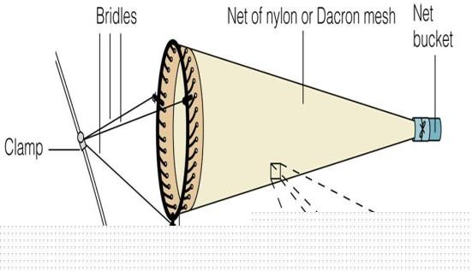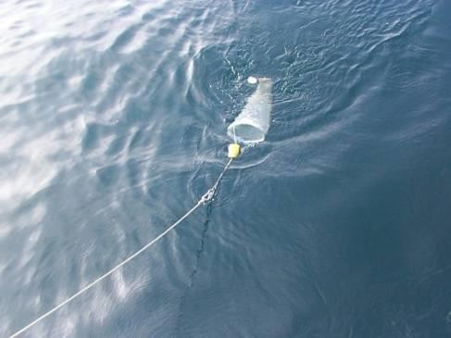

***Figure-9***: Plankton Net

Plankton preservation procedure:

* 1. The water from the collection vessel at the end of the plankton net is transferred to sample bottles.
  2. 5% ethanol is added to the water samples.
* **2.2 Grab Sampler**:

Used for collecting sediment from the bottom for sediment quality analysis and collection and analysis of benthic community present in the location. We have used the grab sampler in our work for collecting benthos Sediment

### Collection procedure of Ekman Grab Sampler:

1. A rope is securely fastened to the grab sampler.
2. The rope’s length is calibrated using a measuring tape. We mark the rope at 5 ft.
3. Set the springs over the knobs and pull the jaws apart.
4. The grab sampler is then gradually lowered into the water, with the rope completely vertical.
5. Lower till the grab hits the bottom.
6. Wait for about 2 to 3 minutes and send a messenger down the line, allowing the springs to close the scoops.

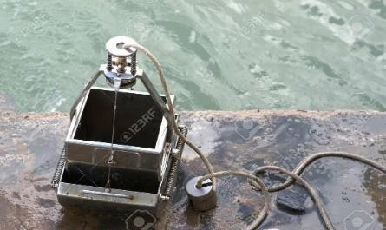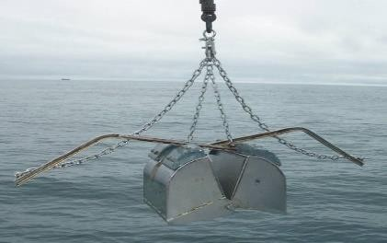

***Figure-10:*** Grab Sampler

### 2.3-Water Multimeter:

Used for measuring the physical properties of water e.g., pH, salinity, conductivity, temperature, DO concentration, etc. Test Procedure for Water Multimeter:

* 1. At first the probe is rinsed with deionized/distilled water.
  2. Electrolyte is poured inside the sensor until it overflows the cap.
  3. We pat slightly to remove the air bubbles from under the probe tip. If the bottom of the cap turns colorless then we understand that no air is trapped inside; the cap bottom remains white otherwise.
  4. Next, we calibrate the sensor by dipping it in distilled water and discard the zero error of the device.

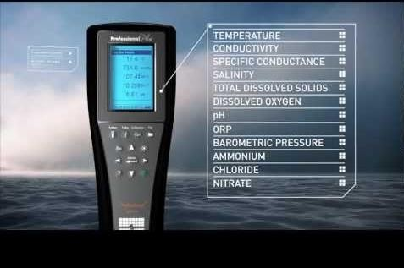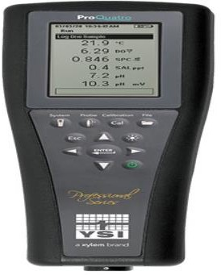

***Figure-11*:** Water Multimeter

### 2.4-Global Positioning System (GPS):

GPS devices can receive information from GPS satellites and calculate the device's geographical position. It shows its users the longitude and latitude of a particular position by this we can determine the position of sample collection. Usage procedure:

1. Press the start button.
2. Wait till the readings become stable.
3. Note the coordinates in the datasheet before proceeding sampling.

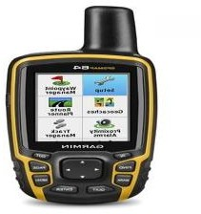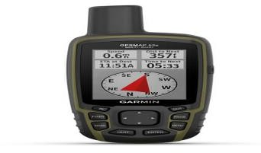

***Figure-12*:** Global positioning system (GPS)

### 2.5-Niskin Water Sampler:

A Niskin bottle is a plastic cylinder with stoppers at each end to seal the bottle completely. This device is used to take water samples at the desired depth without the danger of mixing with water from other depths. The water collected by Niskin bottles can be used for studying plankton or measuring the physical characteristics of the sea.

### Working procedure:

1. At first, we set the release mechanism of the Niskin bottle.
2. Then we attached a strong rope to it for deploying.
3. A messenger was connected to the rope to hit the trigger of the release mechanism.
4. At the end of the rope, we connected a weight for perfect balance.
5. We collected water from 5 different depths: surface, 2-meter, 4-meter, 6- meter, and 8m meters.

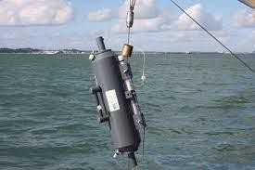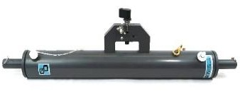

***Figure-13***: Niskin water sampler

### 2.6-CTD:

A CTD, an acronym for Conductivity, Temperature, and Depth, is the primary tool for determining essential physical properties of sea water. It gives scientists a precise and comprehensive charting of the distribution and variation of water temperature, salinity, and density that helps to understand how the oceans affect life.

### Data collection procedure with CDT:

* 1. First, set up our sensor with time limits time intervals, and desired parameters by using Sea Star software via a laptop.
  2. Then we detached the sensor from the laptop and insert the sensor into the yellow packet Fig(b).
  3. After that we tied the packet with a rope and dip the sensor containing the packet into to water.
  4. We put the sensor underwater for our determined time limit (e.g., 30 minutes)
  5. After that we bring out the sensor from the water and detach the sensor from the packet and insert the sensor inside the CTD device.
  6. Then we retrieved data using the Sea Star software and stored data on the laptop. Data is represented as table, graph, and line diagram format.

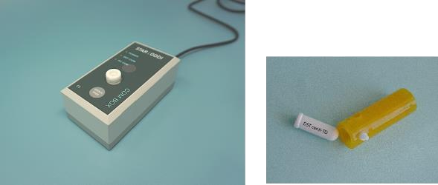

***Figure-14*: CTD**

# Chapter -3: Results and comparative analysis:

|  |  |  |  |  |  |
| --- | --- | --- | --- | --- | --- |
| **Station**  **Number** | **Latitude** | **Longitude** | **DO**  **(mg/L)** | **Temp(°C)** | **Turbidity(ntu)** |
| **1** | 21°47.841' | 90°10.841' | 6.23 | 24.4 | 46.55 |
| **2** | 21°48.875' | 90°7.225' | 5.1 | 25.2 | 37.94 |
| **3** | 21°48.91' | 90°8.118' | 5.2 | 24.8 | 46.33 |
| **4** | 21°48.757' | 90°72.82' | 4.92 | 25.3 | 48.74 |
| **5** | 21°48.813' | 90°7.228' | 4.74 | 25.1 | 79 |
| **6** | 21°48.814' | 90°7.225' | 5.12 | 25.2 | 78 |
| **7** | 21°48.938' | 90°6.774' | 5.1 | 26.9 | 37.39 |
| **8** | 21°49.558' | 90°5.815' | 4.73 | 25.8 | 40.15 |
| **9** | 21°50.24' | 90°5.199' | 4.87 | 25.4 | 42.7 |
| **10** | 21°51.092' | 90°4.867' | 5.39 | 24.6 | 36.92 |

**Comparative analysis**

To better understand the experiments, it’s very crucial to do a comparative analysis. Comparative analysis will help us to visualize things more clearly. Here is the comparative analysis that we have done:

### Comparison between CTD data

We have taken the first ten values from each table. Then we took the maximum values from the tables for each parameter. Then we are comparing between the stations to identify which station has the highest value for individual parameters.

Do,Temperature & Turbidity

Concentration

St.Name DO(mg/L) Temp(°C) Turbidity(ntu)

100

80

60

40

20

0

1 2 3 4 5 6 7 8 9

10

***Figure 15*:** Analysis of DO meter data



Temperature(oC)

Conductivity(mS/cm)

**CHART- 1**

Depth(m)(Below sea Level) Salinity(PSU) Sound velocity(km/s)

30.000

25.000

20.000

15.000

10.000

5.000

0.000

1

2

3

4

5

6

7

***Figure 16*:** CTD Data of Study area 1

8

7

6

5

4

3

2

1

30.000

25.000

20.000

15.000

10.000

5.000

0.000

Chart-2

Temp(°C) Depth(m) Salinity(psu) Conduct(mS/cm) Sound Velocity(km/sec)

***Figure 17***: CTD Data of Study area 2

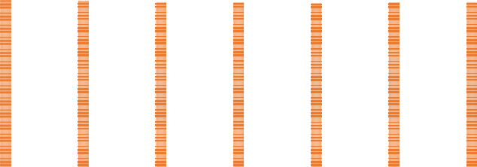

Temp(°C)

**CHART- 3**

Depth(m)(Below aSea Level)

Salinity(psu) Conduct(mS/cm)

Sound Velocity(km/sec)

30.000

25.000

20.000

15.000

10.000

5.000

0.000

1

2

3

4

5

6

7

8

***Figure18***: CTD Data of Study area 3

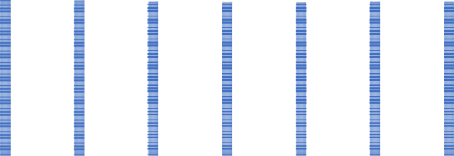

**CHART- 4**

Temperature(oC)

Salinity(PSU)

Depth(m)(Below Sea Level)

Conductivity(mS/cm)

Sound velocity(Km/s)

30.000

25.000

20.000

15.000

10.000

5.000

0.000

1

2

3

4

5

6

7

***Figure 19***: CTD Data of Study area 4

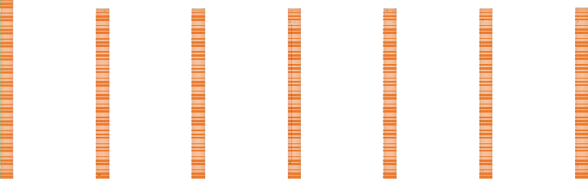

Temp(°C)

**CHART- 5**

Depth(m)(Below Sea Level)

Salinity(psu) Conduct(mS/cm)

Sound Velocity(m/sec)

30.000

25.000

20.000

15.000

10.000

5.000

0.000

1

2

3

4

5

6

7

***Figure 20***: CTD Data of Study area 5

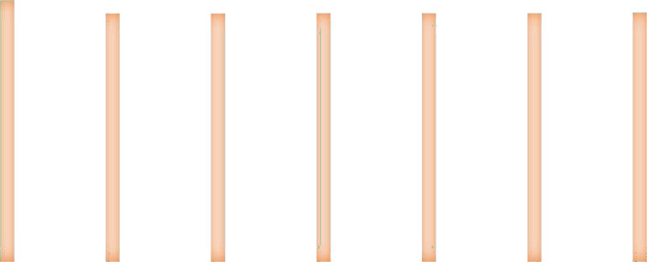

**CHART- 6**

Temp(°C) Depth(m) Salinity(psu) Conduct(mS/cm) Sound Velocity(m/sec)

30.000

25.000

20.000

15.000

10.000

5.000

0.000

1

2

3

4

5

6

7

**Figure 21:** CTD Data of Study area 6

# Chapter-04: Problems & Recommendations

Though Kuakata is a rare, picturesque tourist place in Bangladesh it has some common problems and has some recommendations. Kuakata is endowed with great tourism potentiality with its natural beauty, tribal culture, special events, religious rituals, historical places, forests, and coasting trade, etc. but unfortunately, we could not yet develop the infrastructural facilities which are pre-conditionally needed to turn a place of interest into a tourist destination.

Without developing these facilities, we may not successfully market our tourist products to target market segments. So, we must concern about the problems.

### Problems regarding Kuakata Sea beach

* + - The poor or transportation system.
    - Inadequate exposure and lack of development of surrounding attractions.
    - Inadequate recreation facilities.
    - Inadequate security measures.
    - Lack of control of hotel rent.
    - Lack of control food price in restaurants.
    - Low quality services

### Recommendations

* + - Tourist area of Kuakata to be delineated and declared as tourist spot.
    - Develop the local Transportation facilities such as modern vehicles.
    - Develop road & constructions for better Transportation towards Kuakata.
    - A number of fish processing industries can be set up in and around Kuakata.
    - Land value in Kuakata is increasing day by day with the increase of tourism development activities. So, planning to invest in developing hotels, motels, restaurants, hospitals, clinics, souvenir shops, departmental stores, markets, etc. at Kuakata.
    - A number of seating benches to be established along the beach at certain intervals so that the tourists can take rest while long distance walking along the beach.

**Acknowledgements:** I would like to express my deepest gratitude to my course teacher Md. Solaiman Hossain and Abu Bokkar Siddique for providing me with excellent guidance, cand is, patience during this field trip. Their guidance helps me in all times of this trip and in writing this report.

**Conclusion:** The fieldwork to Patuakhali broadened our understanding of Bangladesh's southern region, which includes the Central Coast. Learning about the many instruments and their applications, as well as working with the collected data and visually expressing it, prepares us for future projects. Getting used to traveling to and working in coastal places provides us experience working in a research mindset. That provides us plenty of reasons to shift our attention to field work.



Thank you